Title: Hydrogen isotopic offsets between soil and xylem water of potted *F. sylvatica* saplings

Abstract NP 200 words

OBS NP has a 6500 word limit. He hecho muchos cambios de edición que tienen como objetivo simplemente recortar el número de palabras.

**Introduction**

Transpiration is the main flux returning water from the land to the atmosphere (Jasechko *et al.*, 2013; Schlesinger & Jasechko, 2014) and thus vegetation plays a central role in the regulation of the global water cycle. To understand land-atmosphere water fluxes we need to identify the water pools accessed by plants and how those change over time and space and the analysis of the natural abundance of water stable isotopes is probably the most widely used technique for this purpose (Evaristo et al. 2015; Barbeta & Peñuelas 2017). This is possible because no isotopic fractionation occurs during root water uptake, as heavy and light isotopes of water diffuse through root membranes proportionately as indirectly observed by Washburn & Smith (1934),. and later confirmed by direct isotopic measurements (Allison *et al.*, 1984; White *et al.*, 1985). Lack of fractionation during root water uptake provided the theoretical basis allowing the use of water stable isotopes to emerge as a powerful tool to infer plant water sources (Dawson & Ehleringer, 1991), assess their spatiotemporal variability (Bertrand *et al.*, 2014; Berry *et al.*, 2014; Barbeta *et al.*, 2015) or their ecological implications (Moreno-Gutiérrez *et al.*, 2012; Rossatto *et al.*, 2013; Stahl *et al.*, 2013; De Deurwaerder *et al.*, 2018). Indeed, concomitant measurements of the isotopic composition of xylem water and its potential sources have contributed to unravel many ecological processes, such as the prevalence of tall sequoia trees in water-limited regions (Burgess & Dawson PCE 27:1023) or ecological niche partitioning in the savannahs (esta es una referencia clásica pero no me acuerdo, por poner un par de ejemplos que no quede así como una frase sin más). Therefore, this is an established technique that has critically advanced our understanding of how plants access belowground (or aboveground) water pools and will very likely keep on doing so in the future.

In recent years, the number of published datasets containing isotopic data of xylem water and its potential sources has increased notably, allowing for large-scale data syntheses (Evaristo *et al.*, 2015; Barbeta & Peñuelas, 2017), which revealed that inferring vegetation water pools from stable isotopes is fundamental for predicting land-atmospheric climatic feedbacks. Due to the higher throughput of water extraction and isotopic determination techniques, the more recent datasets contain more data points than before, and perhaps more importantly, they are no longer restricted to either oxygen or hydrogen isotopes, but routinely present data for both isotopes. In some cases, dual isotope datasets revealed that oxygen and hydrogen isotopes do not always agree in the attribution of the source of plant water. Some authors acknowledged this caveat and use either 2H or 18O to infer plant water sources (Brum *et al.*, 2018). In other cases, discrepancies between 2H and 18O are directly ignored (Brooks *et al.*, 2010; Goldsmith *et al.*, 2018). Importantly, isotopic offsets between xylem water and their potential sources in the dual isotope space have been observed in field sites covering a wide range of soil types and from and across all biomes, including semi-arid shrublands (Wang *et al.*, 2017), boreal needle-leaved woodlands (Geris *et al.*, 2017), temperate broad-leaved forests (Barbeta *et al.*, 2018; Goldsmith *et al.*, 2018), seasonally dry broad-leaved (Bowling *et al.*, 2017) or needle-leaved (Brooks *et al.*, 2010) forests, Amazonian rainforests (Brum *et al.*, 2018; De Deurwaerder *et al.*, 2018) and even rice paddy systems in the tropics (Mahindawansha *et al.*, 2018). These isotopic offsets cannot be attributed solely to methodological issues; for example those ascribed to isotopic determination techniques can be ruled out since isotopic offsets have been found in studies using both mass spectrometers (Brooks *et al.*, 2010; Bowling *et al.*, 2017; Brum *et al.*, 2018; Goldsmith *et al.*, 2018) and laser-based instruments (Geris *et al.*, 2017; Barbeta *et al.*, 2018; De Deurwaerder *et al.*, 2018). On the other hand, confounding effects related to water extraction techniques cannot be completely discarded, since many parameters (such as soil texture, soil humidity, extraction time or temperature) can affect the isotopic composition of soil water retrieved from cryogenic vacuum extraction (Orlowski *et al.*, 2018),. Alternative techniques to the extensively used cryogenic vacuum extractions do exist and it has been show that the isotopic offset between stem and soil water is reduced when using direct vapor equilibration, compared to cryogenic vacuum extraction, in wheat (Millar *et al.*, 2015). However, for woody species, direct vapor equilibration presents additional problems related to the interference of volatile organic compounds, and still needs further development and testing (Raulerson, 2018). In any case, the increasingly frequent isotopic offsets observed across studies tend to share a common pattern with xylem water plotting below and to the right of any considered water sources in the dual isotope space (see the studies above). Such pattern is difficult to attribute solely tosoil water extraction artifacts and potential processes causing isotopic fractionation during root water uptake should be considered and investigated.

The long-standing principle that there is no isotopic fractionation during plant water uptake has already been challenged under certain circumstances. It is well established that the roots of halophytes and xerophytes discriminate against 2H (Lin & Sternberg, 1993; Ellsworth & Williams, 2007; Eley *et al.*, 2014; Redelstein *et al.*, 2018). Although this is generally considered an exception, previously observed isotopic offsets, including our own observations from temperate deciduous forest (Barbeta et al. 2109) may well be caused by discrimination against 2H during root water uptake,. Indeed, in a controlled experiment Vargas *et al.*, (2017) found that the isotopic composition of xylem water was more depleted than the corresponding soil water, especially for 2H. and this discrimination varied with soil water content and texture. The results of Vargas *et al.*, (2017) point to a fractionation process occurring at the soil-root interface that would be affected by soil water content (and indirectly by soil texture). This is in agreement with Ellsworth & Williams, (2007), who suggested that 2H discrimination occurs in the soil-root interface and possibly during water transport through the symplast, due to the lower diffusivity of heavier isotopes through cell membranes (Karan & Macey, 1980). In contrast, Zhao *et al.*, (2016) also found that stem water was depleted in 2H with respect to the most likely source, but they attributed this observation to discrimination during water transport and redistribution. Still, it remains to be addressed whether plant physiological processes underlie observed isotopic offsets.

Here, we conducted a glasshouse experiment with potted *Fagus sylvatica* L. saplings to quantify potential isotopic offsets between plant and source water and to elucidate how these vary with water availability, soil properties and plant physiological performance. Oursoil water availabilities Specifically, we addressed the following research questions (i) is the isotopic offset observed in the field between *F. sylvatica* and its sources (Barbeta *et al.*, 2018) reproducible under controlled conditions? and (ii) what is the role of soil texture, water content and plant physiology in determining potential isotopic offsets? In the field, the total extension of the root system may be unknown, and thus, it cannot be ruled out that apparent isotopic offsets are due to missing to sample a water source (Bowling *et al.*, 2017), in contrast in potted plants there is no possible missing water source. In addition, the application of different treatments allows for the identification and quantification of the effects of plant physiology and soil texture and water content on potential isotopic offsets. .

**Material and Methods**

*Plant material and experimental design*

Our study species was European beech (*Fagus sylvatica* L.), a temperate deciduous tree of great ecological and economic importance for Europe. From February to July 2018 we grew saplings of *F. sylvatica* in a temperature-controlled glasshouse (Talence, France). Climatic conditions inside the glasshouse were monitored with a temperature and humidity probe (HMP60, Vaisala, Vanta, Finland) and a quantum sensor (SQ‑200, Apogee, Logan, UT, US). Ten-minute averages were logged onto a CR6 (Campbell Scientific, Logan, UT, US). Mean temperature over the study period (14 May to 20 June 2018) inside the glasshouse was 20 ± 0.3 °C during the day and 16.3 ± 0.2 °C at night (mean ± se, *n* = 38 days). A shading cloth was permanently deployed from 24 April 2018 and mean daily photosynthetic photon flux density (PPFD) was 10 ± 0.9 mol m‑2 d‑1. One-year old beech saplings were obtained from a commercial nursery (Naudet pépinières, Leuglay, France) from seeds originated from the Armorican massif, in NE France. On 20 February 2018, we transplanted 220 plants onto 3.5 L squared pots filled with three soil types. Soil types consisted of a volume mix of (1) soil: sand: commercial substrate (2:1:1), (2) soil: sand: commercial substrate: crushed rocks (10:5:5:1) and (3) soil: sand: commercial substrate: clay (10:2:5:3). Substrates were: sandy soil from a nearby pine plantation (Jones et al. 2017 HESS, Cestas, France), washed river sand (Gedimat, Levallois-Perret, France), commercial peat substrate for plant growth (“Terrau Gazon”, NFU 44-551, Soufflet Vigne, Martillac, France), crushed rocks obtained from oven-dried (48 h at 105 °C) limestone rocks collected near the Ciron river (Pompéjac, France) and commercial soil conditioner (bentonite clay, Magellan-bio.fr, Cysoing, France). According to texture analyses, first and second (without the rocks) soil types were classified as coarse sand and the third type was sandy loam in the limit of sandy clay loam, henceforth sandy clay loam. Soil total organic C was 33 g kg‑1 and total N was < 1 g kg‑1. We transplanted 100 plants onto the sandy soil, 60 onto the sandy soil with rocks and 60 onto the sandy clay loam.

From February 2018 until 13 May 2018 all pots were watered regularly to field capacity with tap water and pot evaporation was not impaired. On 14 May 2018, we installed plastic tops on each pot to prevent soil evaporation and all pots were watered daily to field capacity for three consecutive days to ensure a homogeneous soil water pool in each pot (cite Vargas et al. 2017 or similar). A set of 12 plants from each soil type continued to be watered to field capacity regularly (control treatment), while watering was withheld for all other plants from the 17 May 2018 until the end of the drying experiment on 20 June 2018 (dry treatment). Mean soil gravimetric water content (GWC) over time for each treatment and soil type was calculated from the weights of ten and five pots for the dry and control treatments, respectively, for each soil type. In addition to the two watering treatments, we applied a low vapor pressure deficit (VPD) treatment on a subset of plants only on the sandy soil (without the rocks), on the first two sampling campaigns. The low VPD treatment consisted on covering five plants with a semi-transparent plastic bag the evening before the measurement day. The aim was to reduce transpiration for individual plants over the course of one day to assess its impact on potential water isotopic offsets between xylem and soil waters.

*Ecophysiological measurements and destructive harvests*

Over the course of the drying experiment, we performed five campaigns of ecophysiological measurements and destructive harvests for water isotopic analysis 1, 8, 15, 28 and 35 days since the last watering event for the dry treatment. On each campaign, we harvested five and three plants from the control and dry treatment, respectively and from each soil type. On the first campaign, all plants were well-watered and we harvested only 20 plants: five for each soil type, plus five from the low VPD treatment (only sandy soil without rocks). The low VPD treatment was only applied on the first and second campaigns (1 and 8 days) and no control plants were harvested on the third campaign (15 days). The destructive harvest consisted on collecting a soil sub-sample from a soil core comprising the whole pot length and homogenized in a clean plastic tray. For each plant we cut two ~5 cm lignified segments, one from the root and one from the steam (separated at least 2.5 cm from the root collar) and then peeled off the bark and phloem tissue. Soil, root and stem xylem samples were transferred into screwcap glass vials, sealed with Parafilm ®and stored in a coolbox until transported to the laboratory where they were kept in the fridge.

Plant ecophysiological measurements were performed in the same plants selected for destructive harvest and included stomatal conductance to water (*g*s), predawn and midday leaf water potential (Ψ). We measured (Ψ) with a custom-made Scholander type chamber (DG Meca, Gradignan, France) on one leaf per plant collected at predawn and at midday. We measured *g*s at mid-morning (10:30-11:30, local time) with two cross-calibrated handheld porometers (SC-1 Leaf Porometer, Decagon Inc., Pullman, WA, US) on one leaf per plant. On the second campaign, we measured *g*s with the two handheld porometers and with an infrared gas analyser (IRGA, LI-COR 6400, LI-COR, Lincoln, NE, US), on the same leaves and matching the conditions inside the chamber (temperature, humidity, PPFD and CO2 concentration) to those prevailing in the glasshouse. The significant correlation between *g*s measurements showed that measurements from the handheld porometers neither over- or under estimated *g*s with respect to the IRGA (*p* = 0.001, *R*2 = 0.45, slope: 1.03 ± 0.25).

*Cryogenic water extraction and analyses of water isotopic composition*

*Data analyses*

**Results**

P1. Soil water content, stomatal conductance, twig water potentials over the course of the experiment.

P2. Isotopic composition of different water pools over the course of the experiment, in this order 1. Control VS Drought, 2. Soil type, 3. Bags.

P3. Isotopic offset, because no effect of soil type, first the effect of the drought treatment is described and then very shortly that of the bags.

P4. Models relating the isotopic offset with other variables (water potential, etc)

**Discussion**

P1. Main finding: when controlling plant water source, we found consistent hydrogen isotopic offsets between the plant and its source. Same magnitude as in the field and to Vargas. Not the case for oxygen. Comment that stem and root are quite similar.

P2. Effect of the drought treatment, possible stem water enrichment, but also effects of the cryogenic extraction (however, those should be stronger thus in the clayey soil…). Finally, comment no effect of soil type, in contrast to Vargas and as we hypothesized based on Oerter etc.

P3. Influence of plant physiological variables and soil water content on the offset. Possible mechanisms.

P4. Implications for the use of stable isotopes, future experiments…

P5. Perhaps concluding remarks…

**Acknowledgements**

References

**Allison GB, Barnes CJ, Hugues MW, Leaney FWJ**. **1984**. Effect of Climate and Vegetation on Oxygen-18 and Deuterium Profiles in Soils. *Isotope hydrology, 1983 : proceedings of an International Symposium on Isotope Hydrology in Water Resources Development*: 105–123.

**Barbeta A, Jones SP, Clavé L, Wingate L, Gimeno TE, Fréjaville B, Wohl S, Ogée J, Ispa UMR, Ornon V**. **2018**. Hydrogen isotope fractionation affects the identification and quantification of tree water sources in a riparian forest. *Hydrology and Earth System Sciences Discussions*: 1–29.

**Barbeta A, Mejía-Chang M, Ogaya R, Voltas J, Dawson TE, Peñuelas J**. **2015**. The combined effects of a long-term experimental drought and an extreme drought on the use of plant-water sources in a Mediterranean forest. *Global Change Biology* **21**: 1213–1225.

**Barbeta A, Peñuelas J**. **2017**. Relative contribution of groundwater to plant transpiration estimated with stable isotopes. *Scientific Reports* **7**: 1–10.

**Berry ZC, Hughes NM, Smith WK**. **2014**. Cloud immersion: an important water source for spruce and fir saplings in the southern Appalachian Mountains. *Oecologia* **174**: 319–26.

**Bertrand G, Masini J, Goldscheider N, Meeks J, Lavastre V, Celle-Jeanton H, Gobat JM, Hunkeler D**. **2014**. Determination of spatiotemporal variability of tree water uptake using stable isotopes (δ18O, δ2H) in an alluvial system supplied by a high-altitude watershed, Pfyn forest, Switzerland. *Ecohydrology* **7**: 319–333.

**Bowling DR, Schulze ES, Hall SJ**. **2017**. Revisiting streamside trees that do not use stream water: can the two water worlds hypothesis and snowpack isotopic effects explain a missing water source? *Ecohydrology* **10**: 1–12.

**Brooks JR, Barnard HR, Coulombe R, McDonnell JJ, Renée Brooks J, Barnard HR, Coulombe R, McDonnell JJ**. **2010**. Ecohydrologic separation of water between trees and streams in a Mediterranean climate. *Nature Geoscience* **3**: 100–104.

**Brum M, Vadeboncoeur MA, Ivanov V, Asbjornsen H, Saleska S, Alves LF, Penha D, Dias JD, Aragão LEOC, Barros F, *et al.*** **2018**. Hydrological niche segregation defines forest structure and drought tolerance strategies in a seasonal Amazon forest. *Journal of Ecology*: 318–333.

**Dawson TE, Ehleringer JR**. **1991**. Streamside trees that do not use stream water. *Nature* **350**: 335–337.

**De Deurwaerder H, Hervé-Fernández P, Stahl C, Burban B, Petronelli P, Hoffman B, Bonal D, Boeckx P, Verbeeck H**. **2018**. Liana and tree below-ground water competition—evidence for water resource partitioning during the dry season. *Tree Physiology*: 1–13.

**Eley Y, Dawson L, Black S, Andrews J, Pedentchouk N**. **2014**. Understanding 2 H / 1 H systematics of leaf wax n -alkanes in coastal plants at Stiffkey saltmarsh , Norfolk , UK. *Geochimica et Cosmochimica Acta* **128**: 13–28.

**Ellsworth PZ, Williams DG**. **2007**. Hydrogen isotope fractionation during water uptake by woody xerophytes. *Plant and Soil* **291**: 93–107.

**Evaristo J, Jasechko S, McDonnell JJ**. **2015**. Global separation of plant transpiration from groundwater and streamflow. *Nature* **525**: 91–94.

**Geris J, Tetzlaff D, McDonnell JJ, Soulsby C**. **2017**. Spatial and temporal patterns of soil water storage and vegetation water use in humid northern catchments. *Science of the Total Environment* **595**: 486–493.

**Goldsmith GR, Allen ST, Braun S, Engbersen N, Romero González-Quijano C, Kirchner JW, Siegwolf RTW**. **2018**. Spatial variation in throughfall, soil, and plant water isotopes in a temperate forest. *Ecohydrology*: e2059.

**Jasechko S, Sharp ZD, Gibson JJ, Birks SJ, Yi Y, Fawcett PJ**. **2013**. Terrestrial water fluxes dominated by transpiration. *Nature* **496**: 347–350.

**Karan DM, Macey RI**. **1980**. The Permeability of the Human Red Cell to Deuterium Oxide (Heavy Water). *Journal of Cellular Physiology* **104**: 209–214.

**Lin G, Sternberg L da SL**. **1993**. Hydrogen isotopic fractionation by plant roots during water uptake in coastal wetland plants. In: Ehleringer J, Hall A, Farquhar G, eds. Stable isotopes and plant carbon-water relations. New York: Academic Press Inc., 497–510.

**Mahindawansha A, Orlowski N, Kraft P, Rothfuss Y, Racela H, Breuer L**. **2018**. Quantification of plant water uptake by water stable isotopes in rice paddy systems. *Plant and Soil* **429**: 281–302.

**Martín-Gómez P, Serrano L, Ferrio JP**. **2017**. Short-term dynamics of evaporative enrichment of xylem water in woody stems: Implications for ecohydrology. *Tree Physiology* **37**: 511–522.

**Millar C, Pratt D, Schneider D, McDonnell JJ**. **2015**. A Comparison of Extraction Systems for Plant Water Stable Isotope Analysis. *Rapid Communications in Mass Spectometry*: 1–4.

**Moreno-Gutiérrez C, Dawson TE, Nicolás E, Querejeta JI**. **2012**. Isotopes reveal contrasting water use strategies among coexisting plant species in a Mediterranean ecosystem. *The New phytologist* **196**: 489–96.

**Orlowski N, Breuer L, Angeli N, Boeckx P**. **2018**. Inter-laboratory comparison of cryogenic water extraction systems for stable isotope analysis of soil water. *Hydrology and Earth System Sciences*: 1–36.

**Raulerson SA**. **2018**. Toward a Diffusive , Non-Destructive Approach to Measuring Stable Isotopes of Water within Tree Stems.

**Redelstein R, Coners H, Knohl A, Leuschner C**. **2018**. Water sources of plant uptake along a salt marsh flooding gradient. *Oecologia* **188**: 607–622.

**Rossatto DR, da Silveira Lobo Sternberg L, Franco a C**. **2013**. The partitioning of water uptake between growth forms in a Neotropical savanna: do herbs exploit a third water source niche? *Plant biology (Stuttgart, Germany)* **15**: 84–92.

**Schlesinger WH, Jasechko S**. **2014**. Transpiration in the global water cycle. *Agricultural and Forest Meteorology* **189**–**190**: 115–117.

**Stahl C, Hérault B, Rossi V, Burban B, Bréchet C, Bonal D**. **2013**. Depth of soil water uptake by tropical rainforest trees during dry periods: does tree dimension matter? *Oecologia* **173**: 1191–201.

**Vargas AI, Schaffer B, Yuhong L, Sternberg L da SL**. **2017**. Testing plant use of mobile vs immobile soil water sources using stable isotope experiments. *New Phytologist* **215**: 582–594.

**Wang J, Fu B, Lu N, Zhang L**. **2017**. Seasonal variation in water uptake patterns of three plant species based on stable isotopes in the semi-arid Loess Plateau. *Science of the Total Environment* **609**: 27–37.

**Washburn EW, Smith ER**. **1934**. The isotopic fractionation of water by physiological processes. *Science* **79**: 188–189.

**White J, Cook E, Lawrence J, Broecker W**. **1985**. The D/H Ratios of Sap in Trees - Implications for Water Sources and Tree-Ring D/H Ratios. *Geochimica Et Cosmochimica Acta* **49**: 237–246.

**Zhao L, Wang L, Cernusak LA, Liu X, Xiao H, Zhou M, Zhang S**. **2016**. Significant Difference in Hydrogen Isotope Composition Between Xylem and Tissue Water in Populus Euphratica. *Plant Cell and Environment* **39**: 1848–1857.

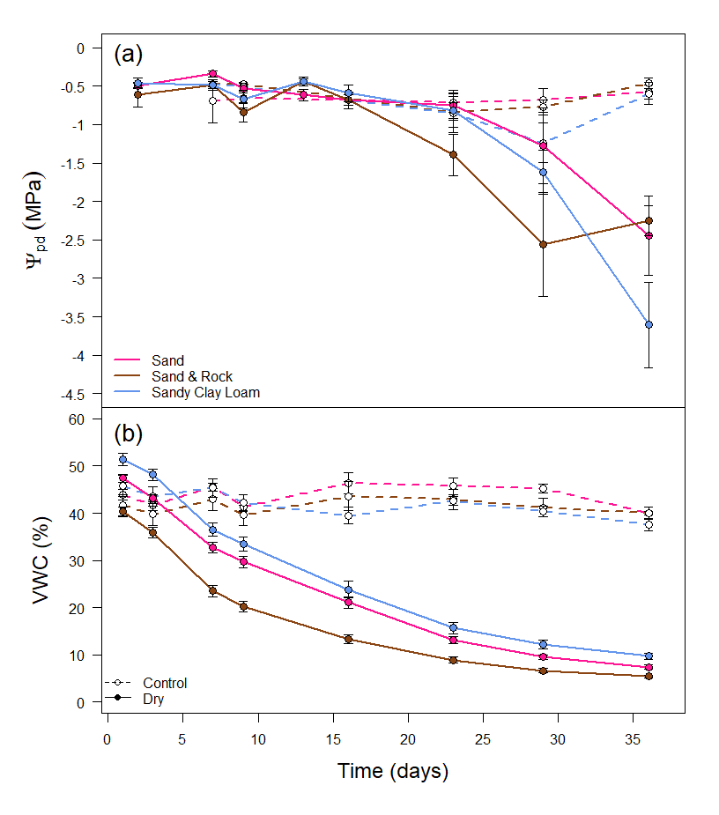

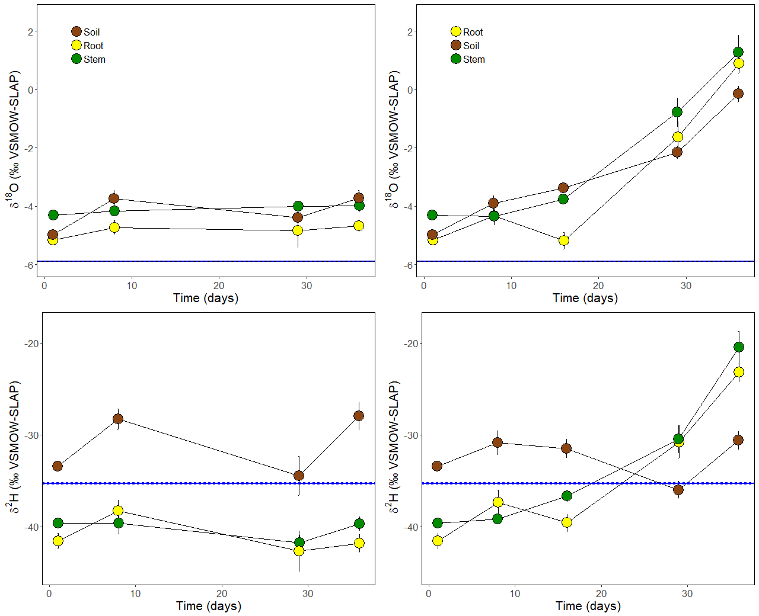

Control



Control



Drought



Drought

Drought

Figure 1

Figure 2

Figure 3

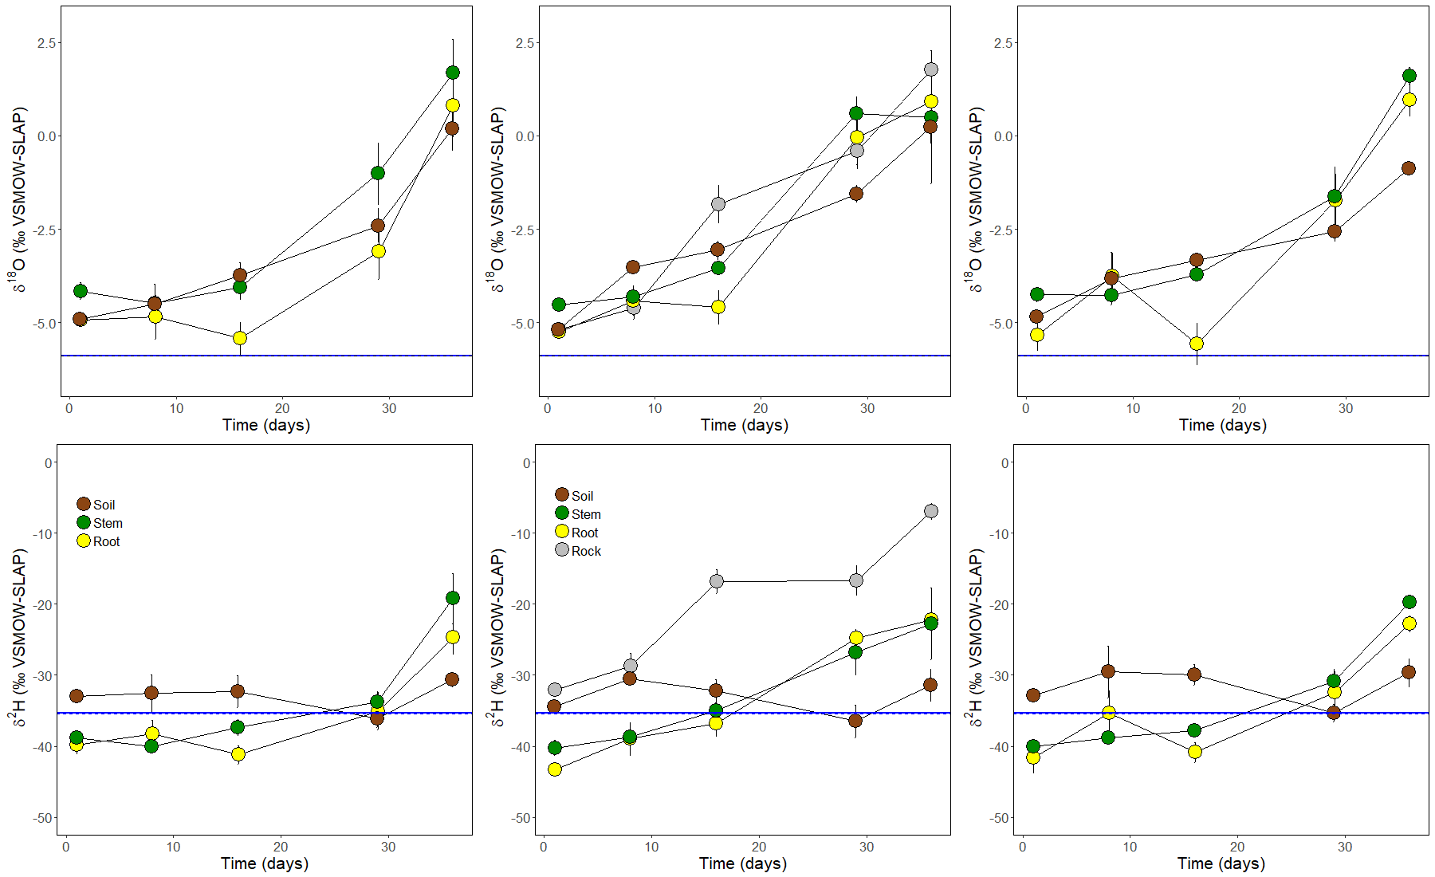

Sand

Sand & Rock

Sandy clay loam

Figure 4

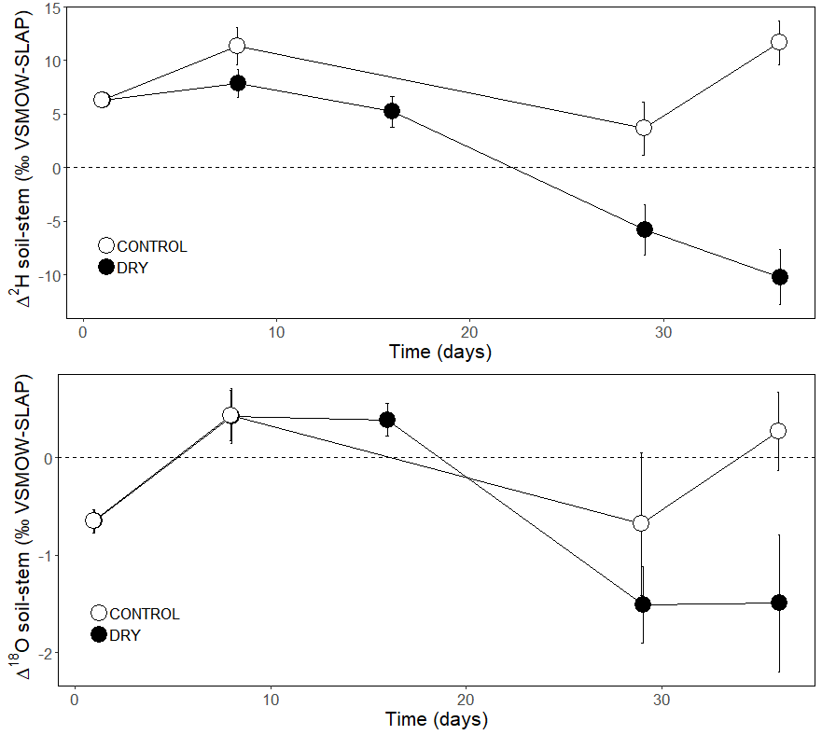

Figure 5

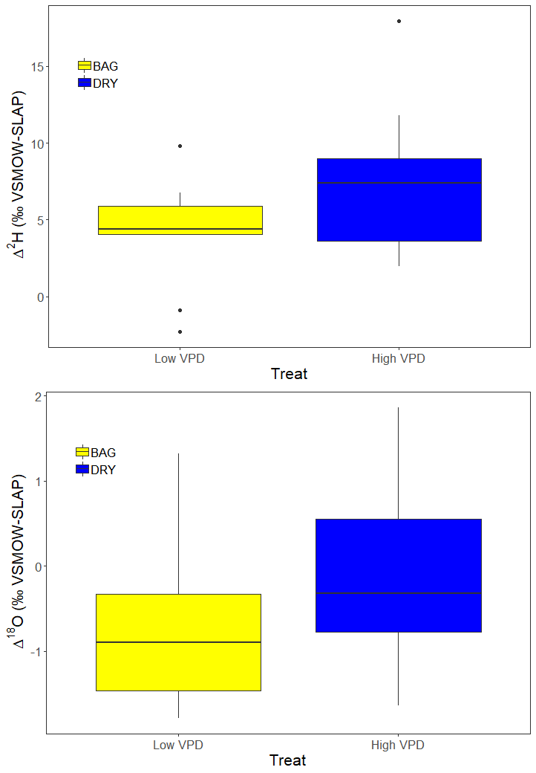

Low VPD

High VPD

Low VPD

High VPD

*

Figure 6

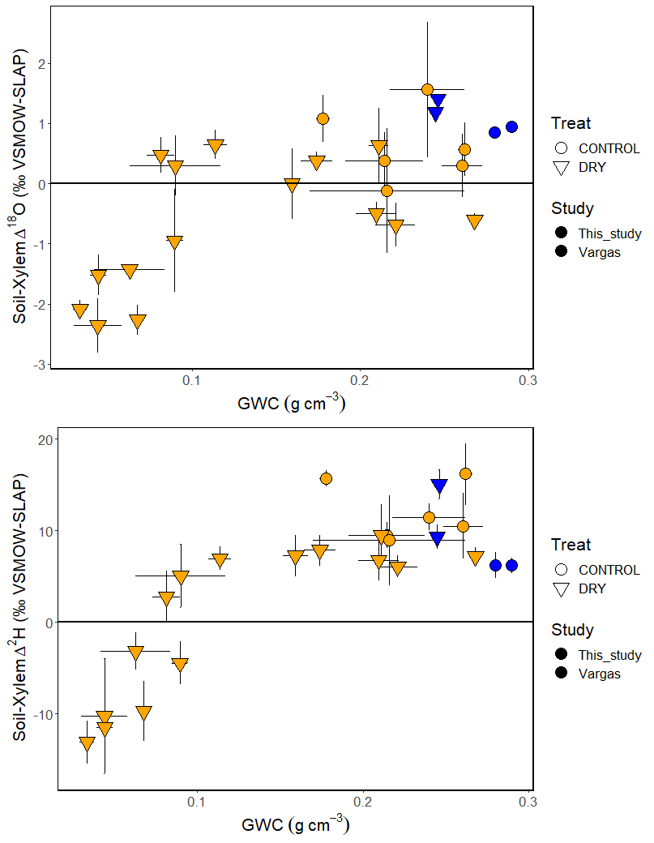

Figure 7

